In this class project, we are going to explore the idea of migrating our IT to the Cloud Computing.

**Phase 1: Team Charter (Team):**

Students will form teams for work on group assignments. The charter will contain at a minimum the following sections:

1. Statement of Need (Current State and Future State)

2. Approach Strategy.

3. Scope.

4. Project Deliverables,

5. Work Breakdown Structure.

6. Timeline.

**Phase 2: Process Flow Diagram (Team)**

Students will create a flow diagram and provide a summary report describing the process flow. As part of the assignment, students will also document the scope of the project/key objectives, evaluate the IT processes, and draft recommendations for improving the effectiveness, efficiency, and quality of specific challenges.

**Phase 3: Proposal (Team)**

Students will create a proposal for IT improvements based on the Process Flow Diagram assignment. Students will address the requirements, issues, stakeholders, and metrics for improvement, problems, and opportunities for improvement in IT.

**Phase 4: Critical Analysis (Individual)**

Students will compile a minimum of six articles on the subject of IT service. For each article the student will write a brief summation of the article’s main points and analyze how these ideas have shaped the IT service management industry. Students reflect on how to provide these methodologies in realistic experiences.

**Phase 5: Service Level Agreement (SLA) (Team)**

Teams will document both the responsibilities as a service provider and of clients receiving services to ensure expectations are met and the common goal is achieved. The document will indicate specific tasks and duties including penalties for not fulfilling the terms within the Service Level Agreement. The Service Level Agreement provides predictable levels of response, availability, and service maintenance.

Let’s begin the class project, by learning a few things about Cloud Computing.

What is Cloud Computing?

* Cloud computing is a model for enabling ubiquitous network access to a shared pool of configurable computing resources.
* Cloud computing and storage solutions provide users and enterprises with various capabilities to store and process their data in third-party data centers.
* Cloud resources are usually not only shared by multiple users but are also dynamically reallocated per demand.
* **…**

Cloud Computing, means “Data Center”, the Big Data.

Data Center, What is it like?

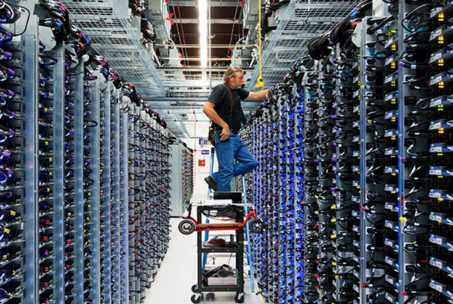

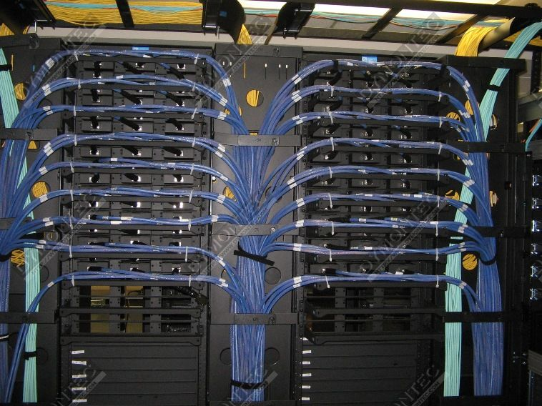

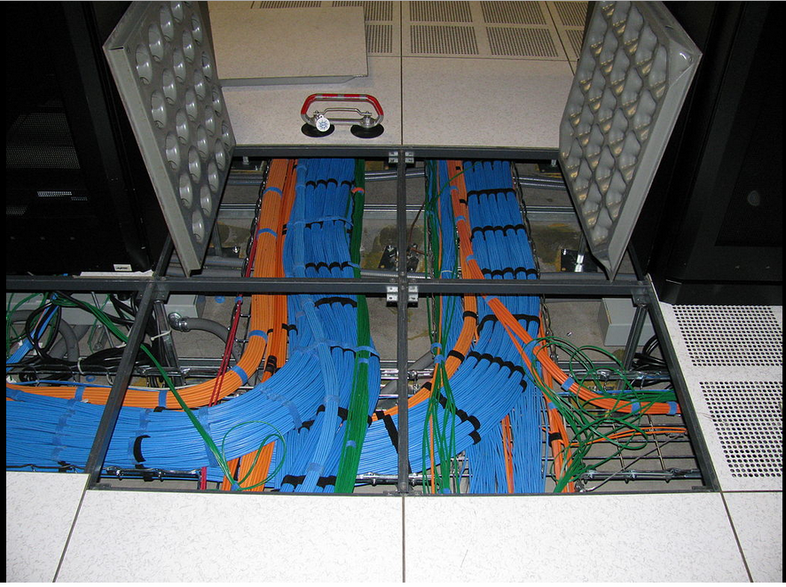

# Storage:

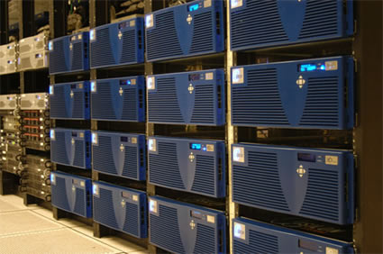

Network:

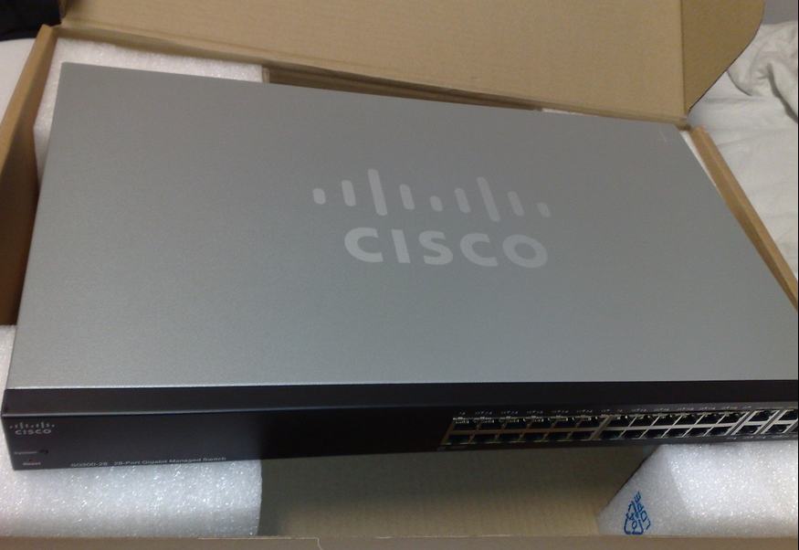

Compute:

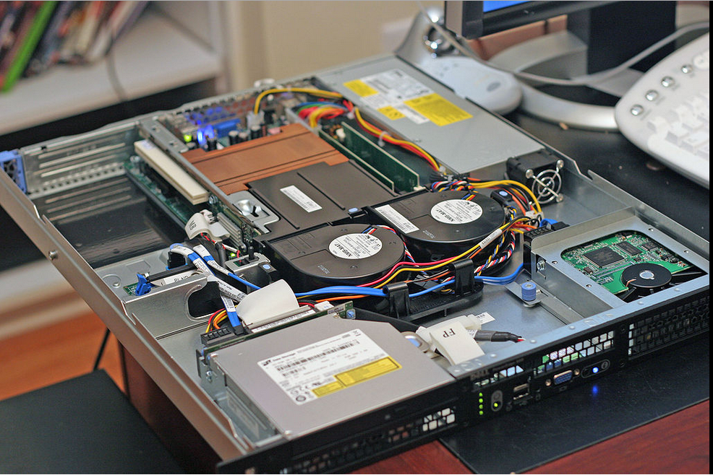

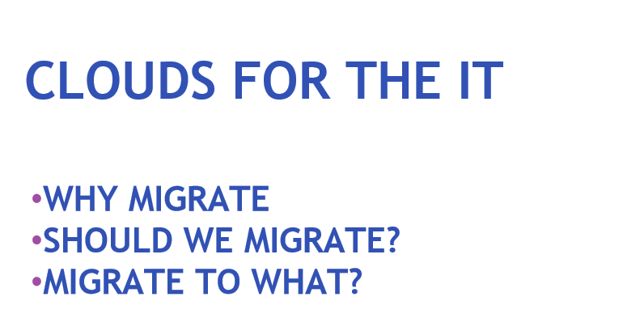

# 

[Relevant to Class Project Phase 1, Task a) Statement of Need (Current State and Future State)]

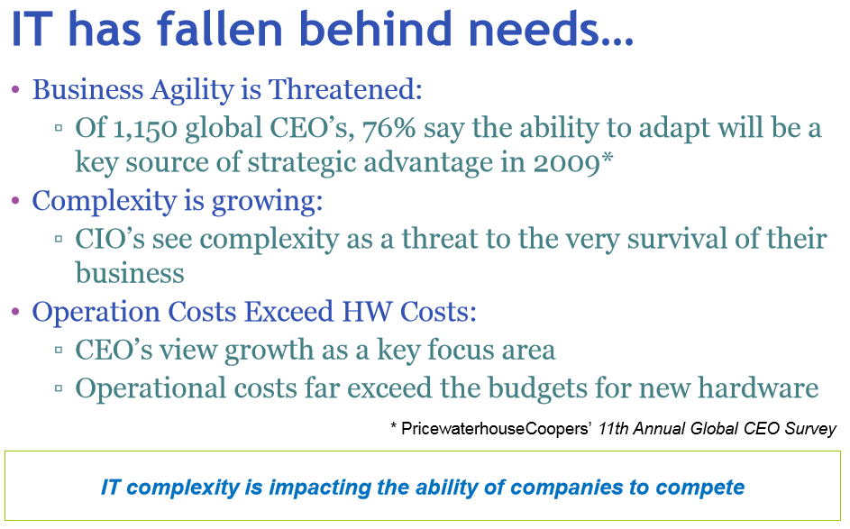

[Relevant to Class Project Phase 1, Task a) ]

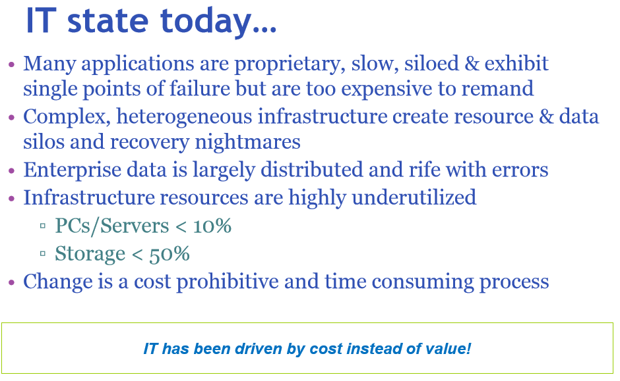

[Relevant to Class Project Phase 1, Task a) b) ]

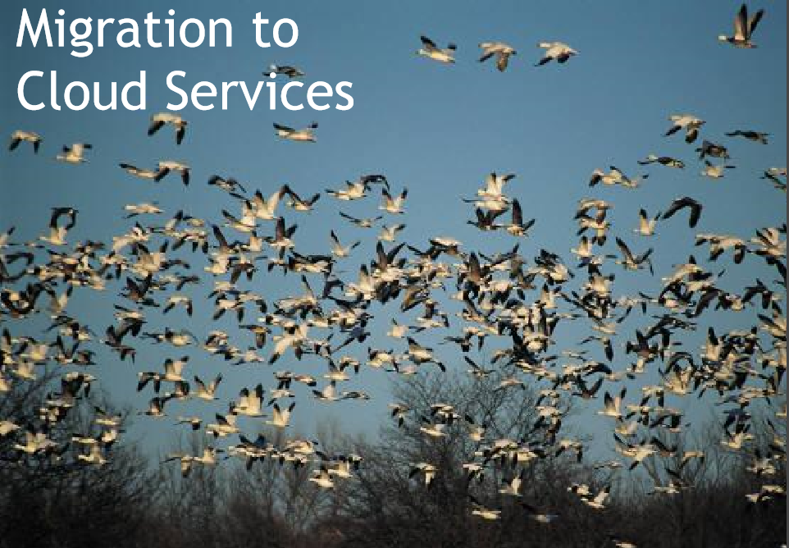

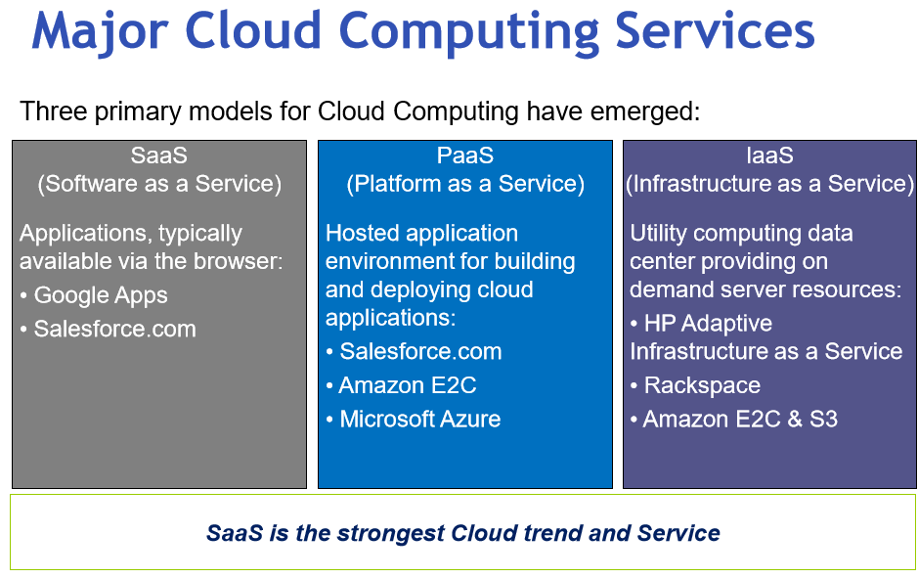

[Relevant to Class Project Phase 1: Task, b) c) d) ]

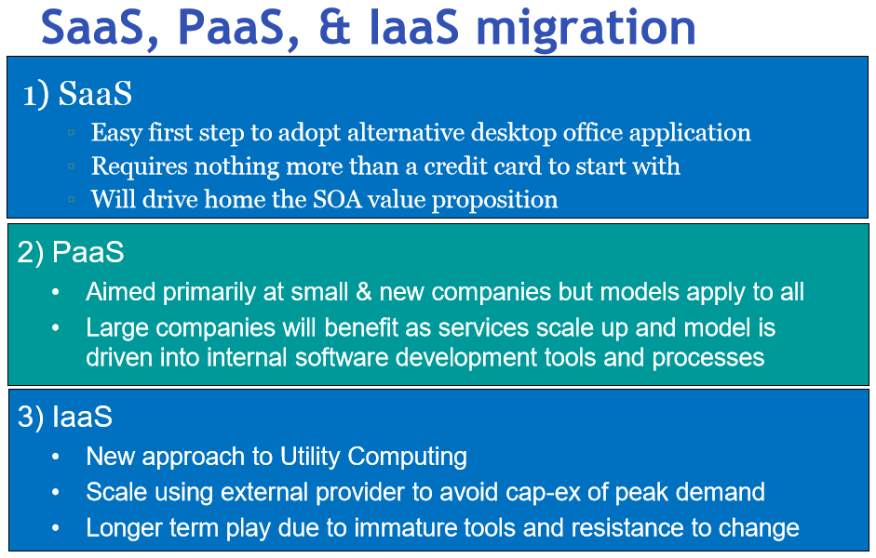

[Relevant to Class Project Phase 1: Task, b) c) d) ]

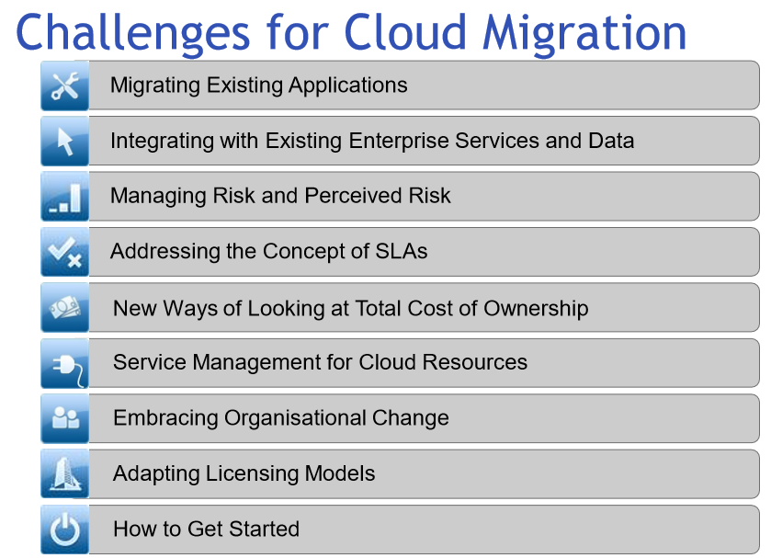

[Relevant to Class Project Phase 1: Task, e), f) ]

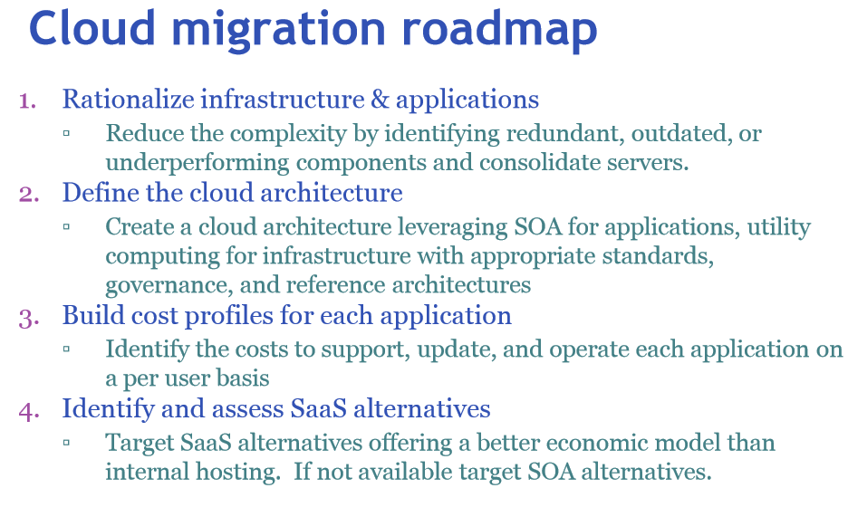

SOA: Service Oriented Architecture.

[Relevant to Class Project Phase 1: Task, c), d), e), f) ]

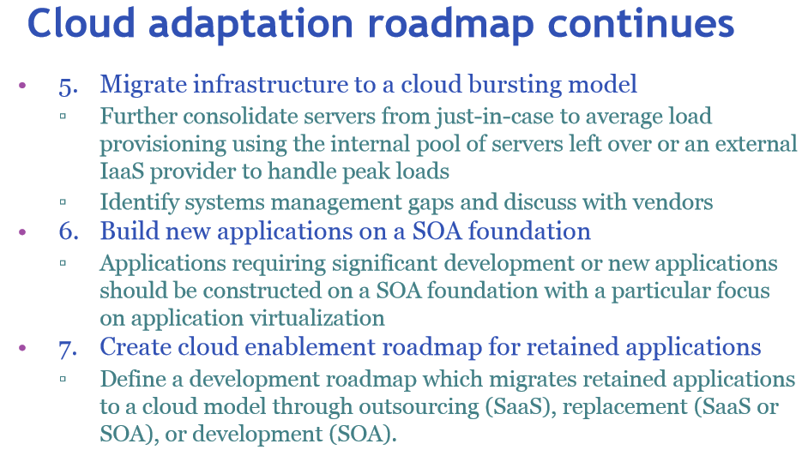

[Relevant to Class Project Phase 1: Task, c), d), e), f) ]

# Appendix 1: Sample SLA Between IT Services and Rocksolid Business Managers

## Introduction

This service level agreement is a formalised and negotiated document between IT Services and its customers, namely the end-users and business managers of RockSolid Corp. This document outlines the roles and responsibilities of both party.

Suggestions for improvement, mistakes noticed, discrepancies, etc, in this document can be addressed to Mr James on 887 879.

## Agreeing parties

The agreeing parties are as follows:

* The IT Services represented by its Manager.
* The Business represented by the Business Manager.

## Period

This SLA will be valid for one year from the date of signature by both parties, with an informal review every three months.

## Reports

The IT Services Manager will generate agreed reports and send them to the Business Manager during the first week of every month.

## Definition of IT support

The IT Service Desk has been set up to provide a single point of contact for RockSolid end-users to contact IT Services for any assistance. IT Services consists of several departments and employees. However, end-users can get all required IT assistance by contacting the Service Desk only.

## Availability summary

The target availability for all RockSolid’s IT services for end-users will be from 8 am to 8 pm on all business days. All maintenance activities will be done after business hours or at weekends, except for emergency and unavoidable equipment troubles.

## Service catalogue: responsibilities of IT Services

IT Services is responsible for the following services to RockSolid end-users (this is also known as the service catalogue):

* All servers and data housed inside the Data Centre.
* All desktop computers, approved applications, printers, scanners installed in various departments of RockSolid Corp.
* All network equipment, e.g. routers, LAN switches, modems and other cabling.
* Providing Service Desk facilities to all end-users.
* A daily full data backup of all servers housed inside the Data Centre.
* The maintenance of access and security privileges – logon IDs, e-mail IDs, access to various servers, etc.
* The provision of necessary software to end-users.
* The monitoring of the equipment.
* The provision of appropriate advice on upgrade requirements.
* Initiating emergency measures, if necessary.
* Maintaining, auditing and upgrading systems software.
* Vendor liaison for solving equipment problems.
* IT disaster recovery planning, testing and end-to-end management of disaster recovery.
* Maintaining up-to-date inventory of equipment in production.
* Reviewing and updating this document periodically and publishing it on the RockSolid intranet.
* Antivirus updates.

## Responsibilities of the end-users and business managers

* Provide adequate forecasts on business volumes, new requirements, increase in employees, etc.
* Release appropriate funds for necessary upgrades, new IT equipment, software licensing, etc.
* Ensure any IT equipment is not misused, abused or experimented upon without a clear understanding of the consequences. Do not test freeware, shareware and hacking tools on the RockSolid network.
* Involve IT Services in all IT aspects related to various projects, capacity planning, new requirements, etc.
* Make staff available to provide the necessary information, documentation and assistance to IT Services resource(s) with regards to resolving support issues.
* Accept and approve recommendations and costs put forward by IT Services from time to time on various support issues. Factor nominal infrastructure down time in project planning and estimation.
* Make no commitment to customers or projects on infrastructure issues without consulting IT Services.
* Do not prevent IT Services from fulfilling their obligations.
* Do not bring, install or use personal equipment and software (non-RockSolid owned) within RockSolid premises.

## Exclusions

IT Services will *not* be responsible for:

* Loading paper to printers, or cleaning IT systems.
* Electrical systems maintenance.
* Ensuring backup of data or files stored on local drives and test servers, unless specifically requested.
* Providing support or maintenance for obsolete and/or nonstandard equipment, or for home PCs.
* Committing 100% service availability for any system or service.
* Providing support or assistance during civil disturbances, war, earthquakes, floods, curfews, terrorist attacks, bomb attack and other extraordinary situations.

## Service Desk hours

Technical assistance is available Monday to Friday, from 8 am to 8 pm, RockSolid business days.

## Response

The standard turnaround time for all incidents will be three hours from time of call. Resolution of the issue may take more time depending on the type of incident.

## Contacting the Service Desk

The IT Service Desk can be reached using any of the following methods:

* Phone number: dial 500 from any telephone.
* Service window: 8 am to 8 pm, Monday to Friday, RockSolid business days.
* E-mail address: [*servicedesk@rocksolid.com*](mailto:servicedesk@rocksolid.com).
* All support requests must be in writing, with a description of the nature of the issue or request.
* Support calls will normally be attended on a first-come, first-served basis.
* Priority will be given to calls that disrupt business.
* After hours and weekend support currently *not* available.

## Call resolution process

Should the users recognise a fault or incident with any service, a call should be placed with IT Services providing information such as business function affected, number of end-users affected, etc. for assessment of severity. Depending on the nature of the call, appropriate action will be initiated. All calls will be given an identification number. Hardware faults will need vendor interaction. Calls will be attended on a first-come, first-served basis. Priority will be given for calls that disrupt business and production servers.

## Issues and limitations

* Non-availability of redundant or standby equipment for all services. One hundred per cent redundancy and standby equipment is not maintained for all equipment and services.
* Limitations on the number of IT support staff available for the number of end-users and equipment to support
* *Ad hoc* major hardware and software requests to IT Services.
* External agencies and vendors not available on 24/7 support or after hours. Turnaround and resolution time may not be met in the event of major problems involving all IT Services members.

## Unpredictable failures

Given the inherent complexities of RockSolid’s IT environment and our reliance on external service suppliers, IT Services will take reasonable steps to protect the integrity of RockSolid’s IT environment, but cannot guarantee that outages will never occur. IT Services can attempt recovery of systems and/or data only after the vendor restores system functionality in the event of hardware problems. Systems can fail during or after office hours. Recovery costs could be involved. IT Services will *not* commit 100% service availability for any system or service, nor guarantee that every incident or issue reported will have an immediate solution.

## Equipment maintenance

IT Services is the owner of all computers, software and network equipment in RockSolid. Equipment will require periodic maintenance and upgrades to function at full capacity. Hence IT Services will have windows for maintenance, which will usually be after hours and at weekends. All major maintenance activities will be notified in advance and will not be classified as down time.

## Escalation procedures

End-users can use the following contacts for escalation if necessary:

|  |  |  |
| --- | --- | --- |
| **Level** | **Name** | **Phone** |
| First | Mr Richards | 333 |
| Second | Mr James | 444 |
| Third | Mr Jones | 555 |

[Open table as spreadsheet](http://library.books24x7.com.proxy.cityu.edu/outputobject.asp?bookid=34427&chunkid=468731046&objectid=nr-N15&objecttype=spreadsheet)

Signatures

IT Services Manager

Business Manager

## 